IN723 Lab 8 BGP Path Preference

In this lab we will manipulate several BGP attributes to influence path selection.
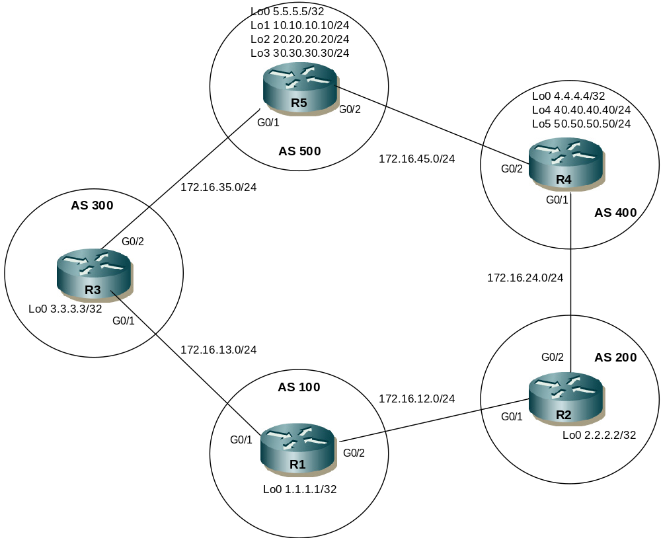

IP Adressing
Router Name | G0/1 | G0/2 | Loopbacks
R1 | 172.16.13.1/24 | 172.16.12.1/24 | Lo0 1.1.1.1/32
R2 | 172.16.12.2/24 | 172.16.24.2/24 | Lo0 2.2.2.2/32
R3 | 172.16.13.3/24 | 172.16.35.3/24 | Lo0 3.3.3.3/32
R4 | 172.16.24.4/24 | 172.16.45.4/24 | Lo0 4.4.4.4/32  Lo4 40.40.40.40/24  Lo5 50.50.50.50/24
R5 | 172.16.35.5/24 | 172.16.45.5/24 | Lo0 5.5.5.5/32  Lo1 10.10.10.10/24  Lo2 20.20.20.20/24  Lo3 30.30.30.30/24

- Note – This lab cannot be completed in packet tracer (unsupported BGP commands). This can be completed in VIRL, GNS3 or the physical lab (if 5 routers available).
- You may need to clear BGP sessions or issue a soft reset for some changes to take effect
- Remember a route-map has an implicit ‘deny any’ at the end. To permit all simply enter a new permit sequence number without any match statements.
e.g
route-map NAME permit 10
match ip address 1
set local-preference 200
<unmatched prefixes passed to sequence 20>
<if no following sequence then unmatched prefixes are dropped due to implicit deny all>

route-map NAME permit 20
<no match statement so allows all>

Step 1 - Physical
- Cable the lab as per the above diagram in VIRL using IOSv nodes.

Step 2 – IP addressing
- Configure IP addressing as per the network diagram.
- Ensure to configure the loopback interfaces. These will be used to source and filter eBGP routes.

Step 3 – EBGP Peering
- Configure fixed BGP router-ids on R1, R2, R3, R4 and R5 using the loopback 0 addresses
- Configure EBGP between each directly connected router as per the diagram. Use the WAN ip addresses for peering.
- Ensure all BGP neighbor relationships are established.

Step 4 – Scenario 1
- Advertise R5’s loopback 1 & loopback 2 via BGP. Configure R1 such that R1’s G0/2 interface is the favoured path to reach R5’s Lo1 route (10.10.10.0/24) & that R1’s G0/1 interface is preferred to reach R5’s Lo2 route (20.20.20.0/24).
- Hint – you will need to configure route-maps on R1 that match the route (referencing a standard ACL) and then set an appropriate value for the BGP local-preference attribute.
- Note that currently the favoured path to both R5’s loopback addresses is via R3 due to a lower AS-PATH length. You could use a single route-map applied inbound to the R2 neighbor that sets a local-preference that is higher than the default (100) for R5’s Lo1 route. You may also decide to set a route-map for the R3 neighbor setting a higher local-preference for R5’s Lo2 route, though it isn’t strictly necessary as it already the favoured path.
- Does this result in any instances of asymmetric routing for traffic between R1 & R5?

Step 5 – Scenario 2
- Advertise R5’s loopback 3 via BGP. Configure R5 such that R5’s G0/2 interface is the preferred path inbound to reach the Lo3 route.
- Hint – Configure an outbound route-map on R5 that sets an attribute to influence traffic coming inbound.
- Does this result in any instances of asymmetric routing for traffic between R1 & R5?

Step 6 – Scenario 3
- Advertise R4’s loopback 4 via BGP. Configure R4 such that R4 advertises Lo4 with a MED value of 500 to R5 and a MED value of 50 to R2.
- Which path does R5 favour to reach R4’s Lo4 network? Why? Hint – this is not a good use of MED, remember how MED is propagated.
- What is the result of configuring ‘bgp bestpath med missing-as-worst’ on R5? (clear ip bgp
Step 7 – Scenario 4
- Advertise R4’s loopback 5 via BGP. Configure R1 such that prefixes originating in AS400 have a preferred path via G0/2.
- Hint – you will need to modify existing route-map (sequence 20). Use a regular expression to match AS_PATHs starting with AS400. Set local pref higher for matching prefixes learned from R2. You can use ‘show ip bgp regexp <regexp>’ to test your regular expression vs the local BGP table.

